Project Design Phase-II
Data Flow Diagram & User Stories

Date | 30 September 2026
Team ID | 6abab772b81abcc53b06d3f7
Project Name | Import Data using Transform Maps (Spreadsheet)
Maximum Marks | 4 Marks

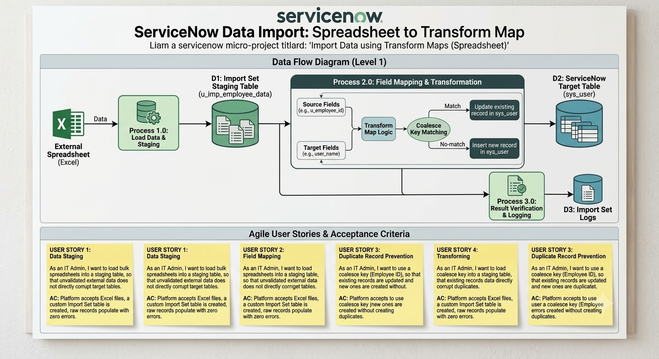

Agile User Stories & Acceptance Criteria

User Story 1: Data Staging & Isolation
As an IT Systems Administrator,
I want to load bulk employee spreadsheets into a staging table using Import Sets,
So that unvalidated external raw data does not directly touch or corrupt core operational tables.
- Acceptance Criteria:
  - The platform accepts Microsoft Excel (.xlsx) files via the Load Data module.
  - A dedicated staging table (u_employee_data_import) is generated automatically with columns matching the spreadsheet headers.
  - Raw source records successfully populate the staging table without row truncation or missing values.

User Story 2: Field Mapping & Automated Transformation
As an IT Systems Administrator,
I want to configure a Transform Map between staging fields and target sys_user fields,
So that source employee attributes automatically populate into the correct ServiceNow target record fields.
- Acceptance Criteria:
  - Source fields (u_first_name, u_last_name, u_email) align accurately with target sys_user fields (first_name, last_name, email).
  - Mapped reference fields (e.g., department) resolve against existing platform records.
  - Choice fields and boolean statuses (e.g., active) map correctly based on source values.

User Story 3: Duplicate Record Prevention (Coalesce Logic)
As an IT Systems Administrator,
I want to designate a unique Coalesce key (Employee ID $→$ user_name),
So that existing user accounts are updated and new records are inserted without creating duplicate profiles.
- Acceptance Criteria:
  - Re-running an import job with existing Employee_ID values updates target records instead of inserting duplicates.
  - Importing a row with a new Employee_ID creates a new record in sys_user.
  - Total unique record count in sys_user matches expected output post-transformation.

User Story 4: Audit Verification & Execution Logging
As an IT Systems Administrator,
I want to review the Import Set execution log after running a transform map,
So that I can verify successful inserts/updates and rapidly identify any failed rows.
- Acceptance Criteria:
  - Import Set Logs display exact counts for Inserted, Updated, Ignored, and Failed records.
  - System logs provide row-level error details if a record fails transformation.
  - Processed records are searchable and verified in User Administration > Users (sys_user.list)

